**Exercises 1: Ethics in Web Development**

**a. Core Principles Review: Based on the lecture, explain why each of the following ethical principles is important in web development:**

**1. User Privacy**

It is important because it protects sensitive user data (e.g., emails, payment details) from breaches, fosters trust and legal compliance (e.g., GDPR). Without privacy, users risk identity theft, discrimination, or exploitation.

**2. Transparency**

Transparency is an important principle in web development because it builds trust by openly communicating data practices (e.g., tracking, ads) and business motives. Users deserve informed consent and clarity about how their data is used.

**3. Inclusivity**

It is important because it ensures equal access for users of all abilities, languages, and devices. Ethical inclusivity avoids discrimination, complies with laws (e.g., ADA), and broadens audience reach

**4. Truthfulness and Accuracy**

It is very important because it prevents harm (e.g., unsafe cooking instructions) and maintains credibility. Misinformation damages user trust and can have real-world consequences

**b. Application to Business Scenario: Reflect on your Assessment 3 business scenario. Identify one potential ethical issue related to each principle discussed in the lecture and suggest how you would address it before beginning development.**

My business scenario is an Online Recipe Book for a business named Tasty Treasures Cookbook. The book has Recipes for every occasion, Categories of recipes, featured recipes, and tips.

1. User Privacy

Potential Issue: Collecting user data (e.g., email sign-ups, cooking preferences) without explicit consent.

**Solution:**

Implement a clear privacy policy explaining data collection and usage.

Use cookie consent banners and opt-in forms for newsletters.

Encrypt stored data and anonymize analytics.

2. Transparency

Potential Issue: Featuring sponsored recipes or affiliate product links without disclosure.

**Solution:**

Label sponsored content with disclaimers (e.g., "Partner Recipe").

Disclose affiliate partnerships in a dedicated "Transparency" page.

Explain how recipe recommendations are generated (e.g., algorithm vs. editorial choice).

3. Inclusivity

Potential Issue: Inaccessible design for visually impaired users (e.g., lack of alt text, poor contrast).

**Solution:**

Follow WCAG guidelines: add alt text to images, ensure keyboard navigation, and use ARIA labels.

Test with screen readers and offer adjustable font sizes/contrast settings.

Provide multilingual recipe translations for non-English speakers.

4. Truthfulness and Accuracy

Potential Issue: Posting untested recipes with incorrect measurements or unsafe cooking times.

**Solution:**

Vet recipes through professional chefs or test kitchens.

Allow user feedback to flag errors and update content promptly.

Add disclaimers for recipes requiring special dietary considerations (e.g., allergies).

**Exercises 2: Reading and Summarise**

1. **WCAG Standards: Review the Web Content Accessibility Guidelines (WCAG). Identify at least two accessibility issues that might arise in your business scenario. Explain how these could affect users and suggest solutions.**

1. Insufficient Colour Contrast

Impact on Users: Low contrast between text and background (e.g., light grey text on a white background for recipe instructions) could make the content unreadable for users with visual impairments, such as low vision or colour blindness. This excludes a significant portion of the audience and violates WCAG’s minimum contrast ratio requirement (4.5:1 for normal text).

Solution:

Use tools like the WebAIM Contrast Checker to ensure text meets WCAG contrast standards.

Implement a high-contrast mode toggle in the website’s settings, allowing users to adjust colors based on their needs.

2: Lack of Keyboard Navigation Support

Impact on Users: If interactive elements (e.g., recipe filters, submission forms, or dropdown menus) cannot be operated via keyboard alone, users with motor disabilities or those relying on assistive technologies (e.g., screen readers) cannot navigate the site effectively.

Solution:

Ensure all interactive elements are keyboard-focusable and operable using Tab, Enter, and arrow keys.

Add visible focus indicators (e.g., outlines) to highlight selected elements for users navigating without a mouse.

1. **W3C Ethical Web Principles: Read the W3C Ethical Web Principles. Discuss how these principles can guide you in making ethical design decisions for your business scenario.**

The W3C Ethical Web Principles emphasize creating a web that is inclusive, respectful, and accountable. Here’s how these principles guide ethical design decisions:

1. Universal Access:

Application: Prioritize accessibility by adhering to WCAG standards (e.g., alt text for recipe images, semantic HTML for screen readers). This ensures users with disabilities can fully engage with the platform.

Example: Designing a recipe submission form with clear labels and error messages to assist users with cognitive disabilities.

1. Transparency and Consent:

Application: Clearly disclose how user data (e.g., saved recipes, dietary preferences) is collected, stored, and shared. Avoid dark patterns like hidden opt-in checkboxes.

Example: Adding a “Why We Collect This” section next to newsletter sign-up forms to explain data usage.

1. User Control and Safety:

Application: Allow users to customize their experience (e.g., disabling auto-play videos, adjusting text size) and report harmful content (e.g., plagiarized or unsafe recipes).

Example: Implementing a “Flag Recipe” button to address inaccuracies or offensive content.

1. Environmental Sustainability:

Application: Optimize website performance (e.g., compressing recipe images, reducing server requests) to minimize energy consumption and carbon footprint.

By aligning with these principles, Tasty Treasures Cookbook can foster trust, inclusivity, and long-term user loyalty.

1. **Review Before and After Demonstration: Compare the before and after example of website available on (https://www.w3.org/WAI/demos/bad/Overview.html). Summaries the takeaways from the comparison.**

Before Issues

• Missing alt text

• Poor contrast

• Keyboard accessibility

• Text was difficult to read

The after version improves navigation, readability, and screen reader compatibility

**Exercises 3: Apply Ethical Principles**

1. **Privacy and Consent: Describe how you will implement privacy controls for your website.**

**Consider the following:**

1. **How will you ensure users understand what data is collected and why?**
2. **How will users be able to control their data or opt out of certain data collection?**

The website will feature a clear privacy policy with plain-language explanations.

Users will have the option to opt out of cookie tracking and request data deletion.

**b. Transparency in Advertising: If your website will feature advertisements or affiliate links,**

**outline how you will clearly communicate this to users to maintain transparency.**

All sponsored content will be labeled as sponsored to maintain transparency.

**Exercises 4: Accessibility Testing**

**Use Lighthouse or WAVE to test a sample website’s accessibility (you can select any existing website). List the accessibility issues identified by the tool. Share the screenshots of the websites and issues identified.**

Website Selected: <https://www.simplyrecipes.com/>

**Findings:**

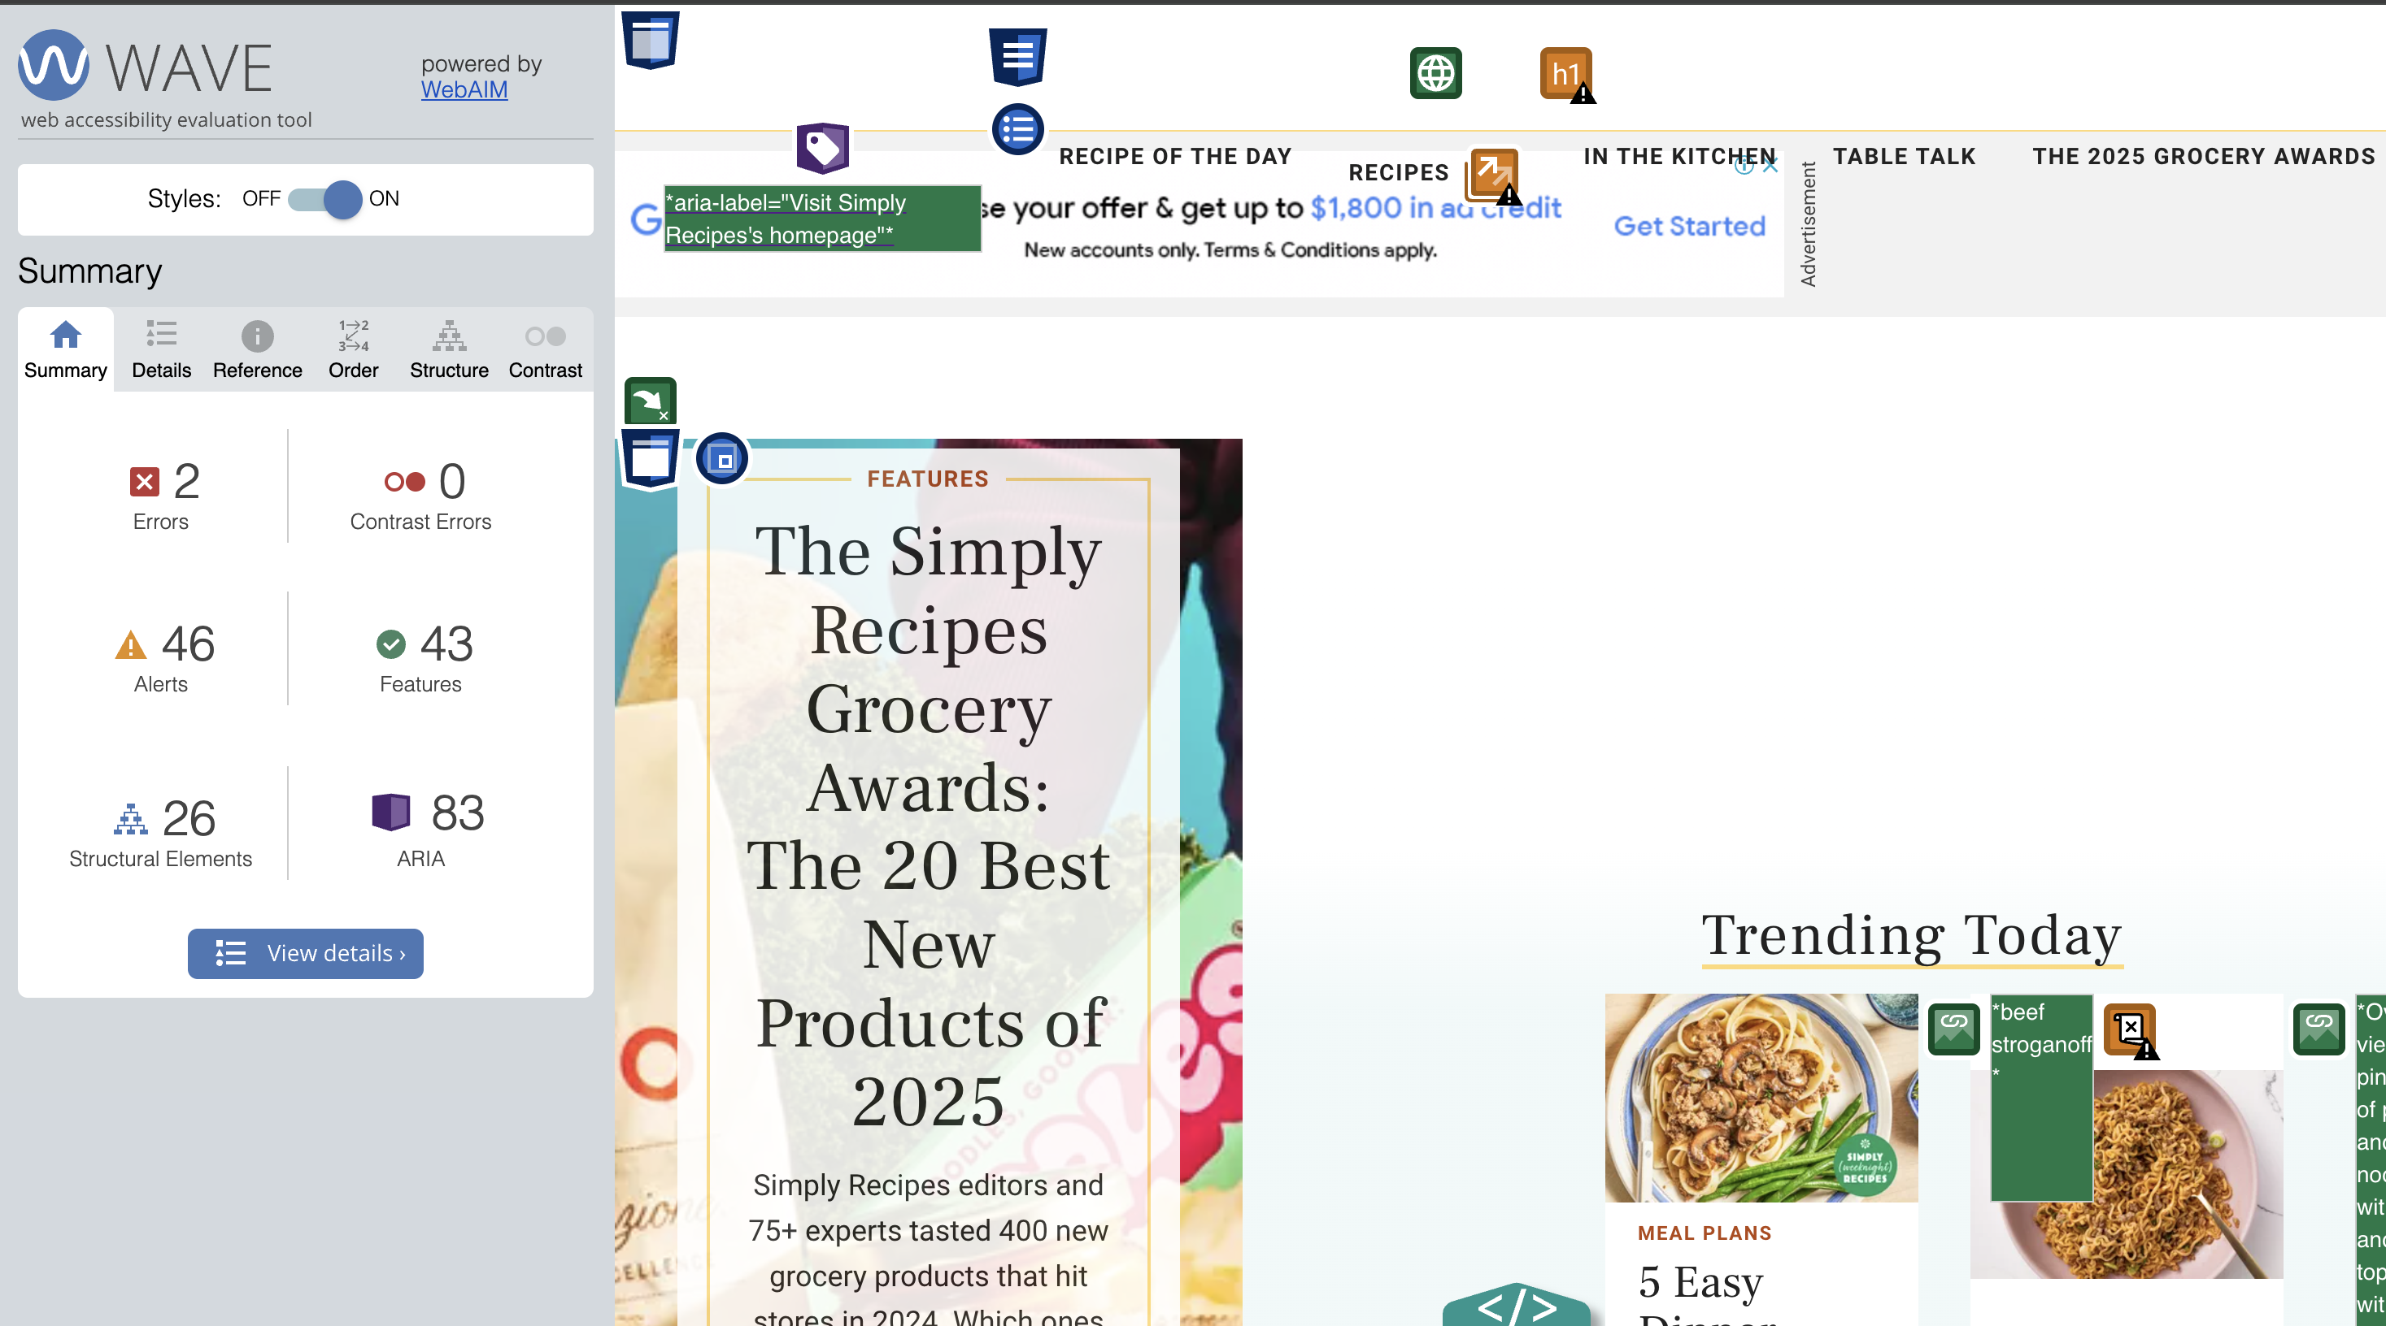

Reduce JavaScript execution time

Minimise main-thread work

Reduce the impact of third-party code

Reduce unused CSS

Reduce unused JavaScript  
Reduce JavaScript execution time

|  |  |  |  |
| --- | --- | --- | --- |
|  |  |  |  |
|  |  |  |  |
|  |  |  |  |
|  |  |  |  |
|  |  |  |  |
|  |  |  |  |
|  |  |  |  |
|  |  |  |  |
|  |  |  |  |
|  |  |  |  |
|  |  |  |  |
|  |  |  |  |
|  |  |  |  |
|  |  |  |  |
|  |  |  |  |
|  |  |  |  |
|  |  |  |  |
|  |  |  |  |
|  |  |  |  |
|  |  |  |  |
|  |  |  |  |
|  |  |  |  |
|  |  |  |  |
|  |  |  |  |
|  |  |  |  |
|  |  |  |  |
|  |  |  |  |
|  |  |  |  |
|  |  |  |  |
|  |  |  |  |
|  |  |  |  |
|  |  |  |  |
|  |  |  |  |

|  |  |
| --- | --- |
|  |  |
|  |  |
|  |  |
|  |  |
|  |  |
|  |  |
|  |  |

**Exercises 5: Ethical and Accessible Design Strategy**

1. **Identify one ethical challenge you may face when converting your static website to a dynamic one. How can you address this challenge in your development plan?**

Handling user-generated content in a way that prevents misinformation.

Implement content moderation, clear community guidelines, and fact-checking procedures.

1. **For your business scenario, describe at least two accessibility features you plan to implement. Justify why these features are important for your users.**

Keyboard Navigation

Screen Reader Compatibility